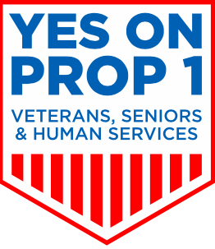

King County Veterans, Seniors, and Human Services Levy
Prop. 1 Endorsement Form

We, the undersigned, endorse the Yes on Prop 1 initiative to pass the King County Veterans, Seniors, and Human Services Levy initiative during the November 7, 2017 election. Since 2006, the levy has created homes, supported men and women who have served, and helped our neighbors. Renewing the levy will cost the typical King County homeowner $45 per year. Eligible low-income seniors, seniors with a disability, and veterans with a 100% service-connected disability will be exempt from this property tax. The levy will raise $350 million between 2018-2023, and these funds will:

- Expand King County’s commitment to veterans and their families.
- Expand King County’s commitment to the most vulnerable members of our community, providing connections to services that restore health and build self-sufficiency.
- Support older women and men, who are the largest growing segment of King County’s population.

Learn about the important services the levy has made possible since its launch in 2006, and what it will support if King County voters renew it this fall at: moving forward, please visit this link.

_________________________________________ ____________________________________ ________________
Organization Authorized Agency Representative Date

_____________________________________________________ _________________________________
Email Phone

Organization Website:

Twitter/Facebook/Instagram:
Does your agency provide services or manage a facility supported with current or past Veterans and
Human Services Levy Funds? Yes☐/No☐
We pledge to support the coalition and help renew the levy in the following ways:

☐Authorize the use of our name and logo in campaign materials
☐Serve as spokespeople for the campaign
☐Mobilize our members, staff, and volunteers to educate and turn out voters
☐Write letters to the editor
☐Contact our members through email alerts or newsletter articles
☐Pledge a financial contribution
☐Host a phone bank
☐Host a campaign event at our site
☐Incorporate VSHS Levy information and voting reminders in our social media

Key contact for Media/Communications:______________________________

Please email this form back to kylie@housingconsortium.org

