May 18, 2020

Bellevue City Council
450 110th Avenue NE
Bellevue, WA 98004

RE: Letter of Support for Ordinance No. 6513- Reduction of Parking Requirements for Multifamily Residential Developments in High Frequency Transit Areas

Dear Mayor Robinson & Bellevue Councilmembers,

As a nonprofit membership association representing a diverse group of organizations working directly in the affordable housing sector, Housing Development Consortium (HDC) members produce and preserve affordable homes across the City of Bellevue, and are committed to development in areas with robust transportation infrastructure and access to opportunity.

With housing and transportation being the two largest expenses for most households, land-use code and regulation that encourages development near high-frequency transit yields wide reaching benefits for the community, environment, and residents. Reducing parking requirements in transit-connected areas of the city will have a significant impact on the total development cost of an affordable housing community, as one off-street parking space costs an average of $60,000.

HDC urges you to support Ordinance No. 6513 which identifies multiple corridors where dependence on a single-occupancy vehicle to live, work and play is not necessary.

Thank you for the opportunity to provide comment on this issue.

With Gratitude,

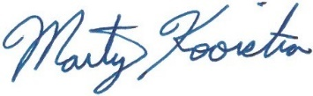
Marty Kooistra Mallory Van Abbema
Executive Director Policy & Advocacy Manager

