Introduction
This May, we will be hosting our 7th Annual Affordable Housing Week (AHW)! This years events will consist of both in-person and virtual events. Robust social media is vital to build momentum and harness energy around affordable housing that is expected with AHW. Whether you are a host or participant, we’d love your voice in sharing the enthusiasm for AHW 2022!
Theme – ALL IN FOR HOUSING!
AHW 2022 is an opportunity for AHW participants to highlight the role affordable housing plays in staabilzing communities and share information on how we can organize for what our communities need to thrive. By being “ALL IN FOR HOUSING,” we want to build momentum to go BIG on housing investments and bold policies that enable comunities to thrive.
Social media tools
Inspire action for affordable homes by using social media to promote #AHW2022! Here's how you & your organization can participate:
- Share quotes/pictures from AWH online events
- Share something you learned about affordable housing needs
- Share a solution/policy you support
- Share city and county proclamations
- Tag & retweet others to amplify #AHW2022 and #All_In_For_Housing #Allin4Housing
Pro tip: Don't start your tweet with @! Far fewer people will see it. A short link to the AHW page is https://bit.ly/3hljwn3.
Draft posts:
“Affordable Housing Week will be on May 8th to 14th! Join the housing movement—for informative & fun events to coalesce around advancing effective housing strategies #AHW2022 #Allin4Housing
“Every year, housing advocates gather around King County to re-energize around housing strategies and build momentum for bold action during #AffordableHousingWeek. Joining us for #AHW2022 May 8-14 and go #Allin4Housing!”
Join us for the 7th Annual Affordable Housing Week Kickoff Event on Monday, May 9 from 3 - 4:30 pm! We are excited to have an amazing panel who will discuss homelessness and affordable housing in King County. Our panelists include HDC Executive Director Patience Malaba, King County Councilmember Girmay Zahilay, and author and Assistant Professor at the University of Washington Gregg Colburn. #AHW2022 #Allin4Housing https://www.housingconsortium.org/calendar/#!event/2022/5/9/affordable-housing-week-kickoff-event

We need more abundant housing in our region! Homelessness is a housing problem. Join us @Wing Luke Museum's Tateuchi Story Theater in kicking off #AHW2022 on May 9th at 3:00pm with this amazing panel to discuss homelessness and affordable housing in King County. The panel includes HDC Executive Director Patience Malaba, King County Councilmember Girmay Zahilay, and author and Assistant Professor at the University of Washington Gregg Colburn #AHW2022 #Allin4Housing https://www.housingconsortium.org/calendar/#!event/2022/5/9/affordable-housing-week-kickoff-event
On #AHW2022 May 10th at 6:25pm we are excited to join @The Urbanist who will host their May meetup conversation with our region’s affordable housing champion @King County Chair Claudia Balducci, who will talking about her vision for the region. #MoreAffordableHomes#AHW2022 https://www.theurbanist.org/calendar/
Happening on #AHW2022 May 10th at 9am is the Veteran, Seniors and Human Services Levy Summit. The VSHSL levy was overwhelmingly renewed by voters in 2017 and is up for renewal in 2023. It has connected hundreds of thousands of veterans, active service members, seniors and vulnerable.
The Veterans, Seniors and Human Services Levy (VSHSL) team is partnering with community groups from across King County to host a series of community conversations to receive YOUR input on issues related to the VSHSL as King County begins to plan for renewal of the VSHSL in 2023. Register to join the Summit on #AHW2022 https://www.eventbrite.com/e/vshsl-2022-summit-registration-267865822887
Community Conversations will be held throughout the spring and summer. The VSHSL Team invites you to join all those relevant to your community! Register to join the summit on#AHW2022 #Allin4Housing https://www.eventbrite.com/e/vshsl-2022-summit-registration-267865822887
- @KingCountyVetsProgram supports veterans through investments and services to improve and stabilize their housing, health, social engagement, and by strengthening King County's network of veterans services #AHW2022 #Allin4Housing
- @KingCountyVetsProgram has created housing and supportive services so that every Veteran returning to King County after serving our country can secure a safe and stable home. Learn more about the great work made possible by this levy www.kingcounty.gov/VSHS#AHW2022 #Allin4Housing

Using a strengths-based approach and leaning on the resiliency of communities who experience vulnerability, VSHSL serves those who—because of current or historical exposure to trauma, violence, poverty, bias, racism, stigma, discrimination, disability or chronic illness—have an increased susceptibility to reduced health, housing, financial or social stability outcomes. Join the VSHSL Summit on #AHW2022 #Allin4Housinghttps://www.eventbrite.com/e/vshsl-2022-summit-registration-267865822887
Check out the Mapping Prevention 2020, a research project funded by VSHSL, on existing efforts to prevent violence, with a focus on strategies that address racism and its intersections with sexism and other forms of oppression. Join the VSHSL Summit on #AHW2022 Allin4Housinghttps://www.eventbrite.com/e/vshsl-2022-summit-registration-267865822887

At the VSHSL Summit on #AHW2022 https://www.eventbrite.com/e/vshsl-2022-summit-registration-267865822887 you can join:
- Exclusive trainings on Diversity Equity and Inclusion, Compassion Fatigue, & Mental Health Literacy
- Interactive workshops from community partners
- Networking fairs featuring human services organizations, serving veterans, seniors, and resilient communities
- Panels and presentations from community partners on issues related to housing, veterans resources, civil legal aid, nonprofit wage and benefits survey, countywide information exchange, embedding equity in management practices, and more!

“Affordable Housing Week is almost here! Will we see you at one of these events? We are excited to see so many housing advocates and residents who care deeply about…. May 8-14 for #AHW2022. Check out the events set for the week https://bit.ly/3hljwn3.”
We all believe that housing is a human right and a cornerstone for thriving and equitable communities #Allin4Housing. Join us for the Affordable Housing Week Kick Off event! #AHW2022 #Allin4Housing https://www.housingconsortium.org/calendar/#!event/2022/5/9/affordable-housing-week-kickoff-event
We believe that everyone should live with dignity in safe, healthy, and affordable homes. #AHW2022 Join us for the Affordable Housing Week Kick Off event! #AHW2022 #Allin4Housing https://www.housingconsortium.org/calendar/#!event/2022/5/9/affordable-housing-week-kickoff-event

Hashtags - #AffordableHousingWeek; #AHW2022; #All_In_For_Housing; #Allin4Housing

Twitter:
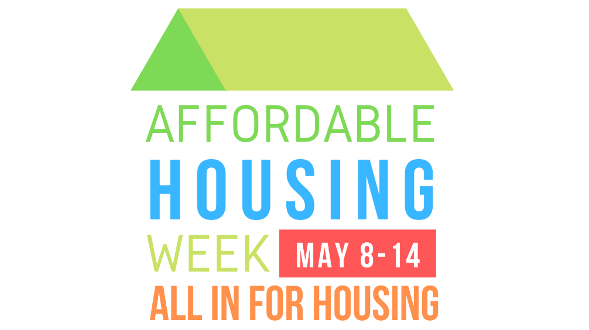
Facebook:

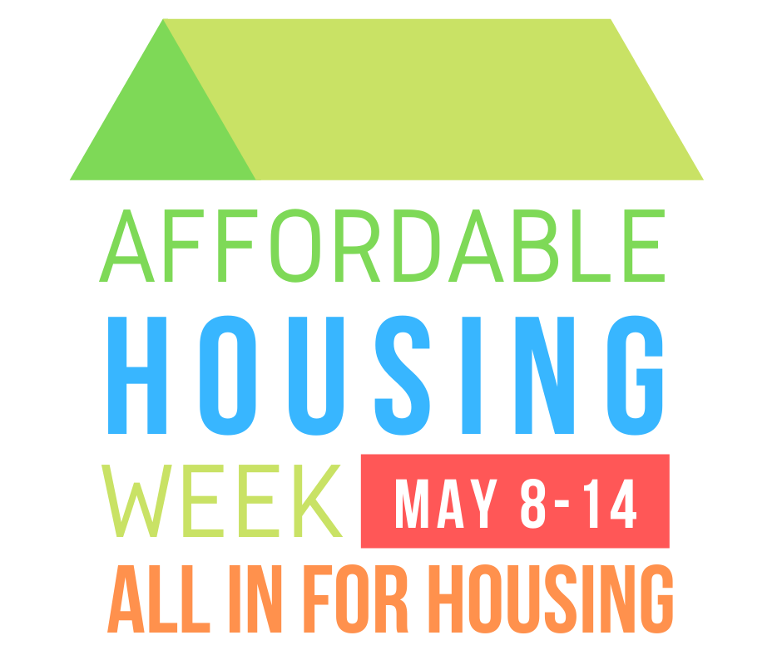

Media Outlets:

Seattle Times: @SeattleTimes
Project Homeless: @TimesHomeless
The Stranger: @TheStranger
KUOW: @KUOW
KIRO 7: @KIRO7Seattle
Auburn Reporter: @AuburnReporter
Bellevue Reporter: @BelReporter
B-Town (Burien) Blog: @btownblog
Bothell-Kenmore Reporter: @Bothell_Kenmore
Crosscut: @Crosscut
Kent Reporter: @KentReporter
Kirkland Reporter: @KirklandReport
Mercer Island Reporter: @MIReporter
Redmond Reporter: @RedmondReporter
Renton Reporter: @RentonReporter
South Seattle Emerald: @SoSeaEmerald
Shoreline Area News: @Shorelinearea
The Urbanist: @UrbanistOrg
Tukwila Reporter: @ TukwilaReporter
Woodinville Weekly: @WdvlWeekly

Governments:

Bellevue: @BellevueWA
Bothell: @CityofBothell
Burien: @Burien
Covington: @CovingtonWash
Des Moines: @DesMoinesWA
Duvall: @CityofDuvall
Federal Way: @WAFederalWay
Issaquah: @CityofIssaquah
Kenmore: @KenmoreWA
Kent: @CityofKent
King County: @KingCountyWA, @KCCouncil, @KCExec
Lake Forest Park: @CityofLFP
Mercer Island: @MercerGov
Newcastle: @CityofNewcastle
Redmond: @CityOfRedmond
Renton: @CityofRenton
Sammamish: @CityofSammamish
Seattle: @SeattleCouncil
Shoreline: @ShorelineWAGov
Snoqualmie: @SnoqualmieGov
Tukwila: @CityofTukwila
Woodinville: @WoodinvilleCity
… and us! @HDC_SeaKC

