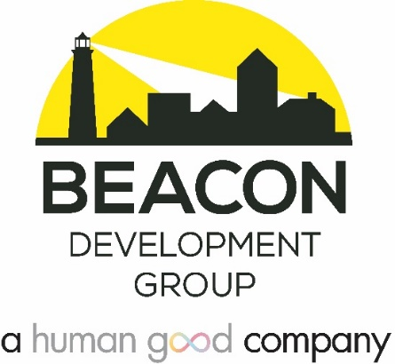

JOB DESCRIPTION FOR:
Housing Developer II (Project Manager)
Apply here: APPLICATION LINK
Beacon Development Group (a HumanGood Company) is hiring a Housing Developer (HDII). This person works with supervision in the areas of development of new project proposals, feasibility, pre-development review, project construction/rehabilitation management, and public / private financing for new and rehabilitated housing for low-income households. The HDII position is responsible for supporting all aspects of project development from planning to closeout. The scope of this position’s responsibility may include the following: assessment of community needs, identification and acquisition of appropriate sites, formulation of feasible housing proposals, development and operating budgets, project schedules, assisting the sponsor in conducting community notification, preparation and review of funding applications, and coordination of the project development team, including external consultants.

Beacon has been providing affordable housing development services for 25 years and is one of the most respected firms of its kind on the west coast. We are a mission driven organization that serves the housing needs of its community, its clients, and its parent company HumanGood.

ESSENTIAL JOB FUNCTIONS

Feasibility Analysis
- Researches and develops information required for project concept development.
- Researches and develops realistic project capital and operating budgets.
- Provides research and due diligence on funding sources and site acquisition.
- Underwrites and analyzes project financing including construction loans, permanent debt, tax-exempt bonds and Low-Income Housing Tax Credits.

Funding Sources
- Maintains open and positive relationships with public funders, investors and financial institutions.
- Identifies appropriate funding and subsidy sources for each development project.
- Works with sponsors to understand loan terms, contracts, and other documents.
- Prepares clear and effective private and public funding applications.
- Negotiates funding documents with various funding sources and LIHTC investors.

Project Management
- Oversee project schedule and budget throughout entire project lifecycle;
- Maintains positive working relationships with client/owner and all external team members;
- Collaborate with Beacon Construction Managers on design and construction process;
- Oversee monthly financial draws, cost certification process, and project close-out.

External and Internal Development
- Supports BDG Team in identifying and responding to Requests for Proposals.
- Represents Beacon on external committees and boards.

MINIMUM REQUIREMENTS
- BA or graduate degree in finance, public administration, business, or related field; demonstrated successful experience (2 years) in multi-family affordable housing development may be substituted;
- 2+ years experience in affordable housing;
- Experience working with various types of public and private financing (e.g. bank loans, bridge loans, Tax Credits, etc.);
- Leadership, communication skills, commitment to mission, and experience working in diverse groups.

SALARY AND BENEFITS
Salary range: $90,000-$110,000

Location: Employee will be based in our Seattle office; some travel required; hybrid work environment expected

Beacon/HumanGood offers competitive pay and phenomenal benefits. Eligible positions (30+ hours/week) start with 20 paid days off, plus seven holidays, a company-matching 401(k) and health plans that give you cash to use for those unexpected health issues. We also offer a Tuition Reimbursement to promote your career advancement.

For more information, go to: beacondevgroup.com and HGcareers.org

